**Standard Operating Procedures**

**Fiware**

**Application Support Document**

Version 2.0

Version Control

|  |  |  |  |  |
| --- | --- | --- | --- | --- |
| Version No | Version Date | Types of Changes | Owner/Author | Date of review /expiry |
| 1.0 | 07/29/2011 | Creation | Amit Athavale |  |
| 1.2 | 1/31/2013 | Added printers, Update all sections | Ryan Ferguson |  |
| 1.3 | 7/8/2013 | Multiple updates for Leasing transition | Ryan Ferguson |  |
| 1.4 | 8/21/13 | Added Check processing info | Amy Dunn |  |
| 1.5 | 9/12/13 | Adjusted SLA | Amy Dunn |  |
| 1.6 | 10/16/13 | Payload Verification process added | Saubhagya Pradhan |  |
| 1.7 | 01/24/16 | Updated server name, contact details | Samkit Jain |  |
| 1.8 | 03/08/18 | Check Processing, Services, Modification as per the current activity | Aakash Mishra |  |
| 1.9 | 10/21/2019 | Updated Section G – Access provisioning to show new link oneIDM | Ron Thompson |  |
| 2.0 | 6-1-2023 | Updated various sections to reflect migration to AWS cloud environment | Ron Thompson |  |

Contents

A. Check List 4

B. Application Overview 5

C. Process Flow 5

D. Architecture 5

E. Server Details 6

F. System Security 7

G. ID Management / User Access 7

H. Manually Requested Tasks 12

I. Check Processing 21

J. Fiware Service Maintenance 24

K. Monitoring Plan 26

L. Documentation………. ………………………………………………………………………….…28

M. Required Support software 28

N. FMEA 28

O. Production Deployment 29

P. Operational Procedure 29

Q. Disaster Recovery 29

R. Server and Data backup details 29

S. Communication Queues 29

T. SLA 30

U. Communication DL 30

V.Contact List…………………………………………………………………………..………………30

W. Misc…………………………………………………………..……………………………………...31

# Check List

## Template Instructions

* If something is already documented in a controlled environment (iSet, Libraries, GE Folders) that is regularly updated, there is no need to integrate it into this document. Just be sure to include how and where this document can be found. If the document is not monitored or updated it would be a good idea to integrate it into this document.
* If a section doesn’t make sense for this system then remove it. If a section should be added then add it.
* Feel free to include embedded files where appropriate
  + INSERT > OBJECT > CREATE FROM FILE > DISPLAY AS ICON

|  |  |
| --- | --- |
| **RUN Transition Check List** | |
| **Status** | **Task** |
| Complete | Is all information in Service Now up to date? |
| Complete | Existing Documentation is in a public location where RUN Team can view? |
| Complete | Has RUN Team been provided all required access to take over this system? |
| Complete | Have helpdesk forms and Clarify been configured to send P1/P2 to RUN Team? |

# Application Overview

Fiware is a vendor system, which runs internally on GE servers and is used to print checks and maintain a record of the check (check number, bank, date, payee…). The software vendor is Sure pay Financial Services. Fiware is used by the Capital Solutions Organization to print checks. Fiware receives files from several systems (Leasewave, Oracle SSS) and reformats them and loads them in Fiware.

Fiware is a vendor (Surepay Financial Services) check printing application, which runs on GE servers and is used by GE HFS and Corporate Tax for disbursements related check printing activities. Checks are printed via Fiware on a dedicated check printer with access restricted to designated personnel. The types of checks printer are:

1. GE HFS - Primarily for new deal funding and customer reimbursement requests.
2. Corporate Tax – Primarily for State and Local income tax return checks for the Industrial Businesses

Fiware application is accessed using below URL:

1. Prod URL : http://fiware.cloud.health.ge.com/
2. QA URL : <http://fiwareqa.cloud.health.ge.com/>

|  |  |
| --- | --- |
| Location and Number of Users: | **USA** |
| Total User Population: | Total 15 Users |
| Target Audience of Application: | Internal |
| Availability | M-F 5AM-10PM EST |
| Additional Considerations: | NA |

# Process Flow

Data process flow.



High-Level Flow

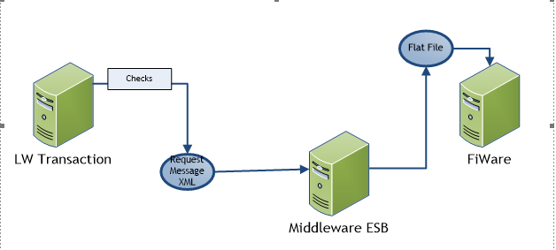

# Architecture

FIWARE Technical Architecture is provided below

**.**

# Server Details

* **Server details:**

|  |  |  |  |
| --- | --- | --- | --- |
| **APPLICATION - Server Details** | | | |
| **Server Name** | **Environment** | **IP** | **Comments** |
| h16129-2. MGMT.CLOUD.DS.GE.COM | Production | 10.229.169.246 |  |
| h15332-2.mgmt.cloud.ds.ge.com | QA | 10.229.173.46 |  |
| Bastion tunneling server: | Production | 10.229.191.140  10.229.172.253 |  |
| Bastion tunneling server: | QA | 10.229.191.140  10.229.172.253 |  |

|  |  |  |  |
| --- | --- | --- | --- |
| **WEB - Server Details** | | | |
| **Server Name** | **Environment** | **IP** | **Comments** |
| h16129-1. MGMT.CLOUD.DS.GE.COM | Production | 10.229.173.138 |  |
| h15332-1.mgmt.cloud.ds.ge.com | QA | 10.229.166.96 |  |

|  |  |  |  |
| --- | --- | --- | --- |
| **DATABASE - Server Details** | | | |
| **Server Name** | **Environment** | **IP** | **Service Name** |
| prd1fiw.c67zpurmgqn7.us-east-1.rds.amazonaws.com | Production |  | PRD1FIW |
| stg1fiw.c67zpurmgqn7.us-east-1.rds.amazonaws.com | QA |  | stg1fiw |

# System Security

## INTRODUCTION:

* + - * In Fiware Security is achived through following objects
* User
* Application
* Group
  + - * By creating above objects and assigning them in such way that user have minimum access.

## GROUPS- APPLICATION ASSIGNING:

* + - * There is provision that we can create different applications and groups as per requirement.
      * After creating them we can assing each application to some group. One application can be assging to different group.
      * Each combination can be assgined different function.
      * In such way groups can be assinged limited functionality.

## GROUPS – USER ASSIGNING:

* + - * After creating different groups and user, users are assinged to groups.
      * Each user can be asssigned different groups.
      * In such way users are given access to checks of that perticular group and restricted to work in that group only.

# ID Management / user Access

* Fiware access request comes through IDM portal **idm.ge.com**.
* The IDM/SN request should tell which user id should be used to clone.

User access to Fiware is currently provisioned through One IDM Portal link [**https://oneidm.ge.com/**](https://oneidm.ge.com/) **.**

Application = Fiware PROD

* **Create/Modify User ID:**
* User raise an IDM Support Request using above IDM link and selects “Fiware” in the application filter.
* User selects the Requestor Role and completes the Comments text box, which should include the business justification and user ID to clone, and submits the IDM request.
* The Fiware Run support team once the IDM request is approved will resolve the request and provision the user in Fiware.
* **Disable User ID :**
* User/User’s Manager opens up a case using helpdesk OTR application form. Once case is received, RUN

Team disables the user ID from the application.

* **User ID Audit :**
* User IDs are reviewed annually. Users that no longer require access to Fiware are disabled.

## User creation in Fiware:

**Step 1**:

Login to Fiware.

Click on System Config -> System Configuration -> click on Users tab on Right -> View Users.

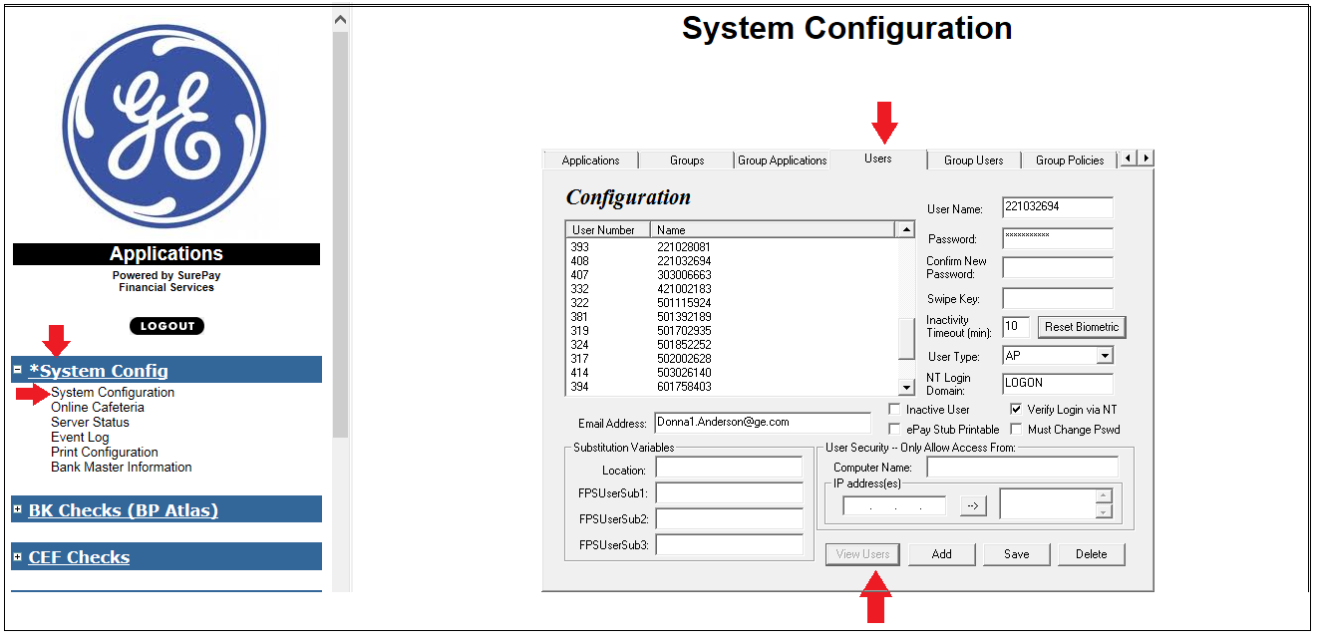

**Step 2:**

* Select an existing user to clone -> add new user **sso** in User Name field->keep password and confirm new password field blank -> Add user email address in Email Address field.

Verify that the fields are correct and update as needed:

**Note:** the User Type should agree to the IDM Request.

* Inactivity timeout, User Type, NT Login Domain, Verify Login via NT.
* Click on Add. Click ok on the pop window. The New users will be added.
* **IMPORTANT**: Do not click “**Save**” otherwise the users ID that was cloned will be updated with the new users info.
* **Temp password change:**
* If the Login via NT is not checked then we have to put the temp password to password text box and the same needs to be entered in confirm new password.
* If password is set manually then, user will need to change the temporary password after first login.
* Once the id is created without Login Via NT, please share the password with the user and ask them to change the password using below steps
* Login to Application -> System configuration -> Online Cafeteria -> User Options
* Enter the old password provided by the Run team and then Set the new password as per you and the click on save options

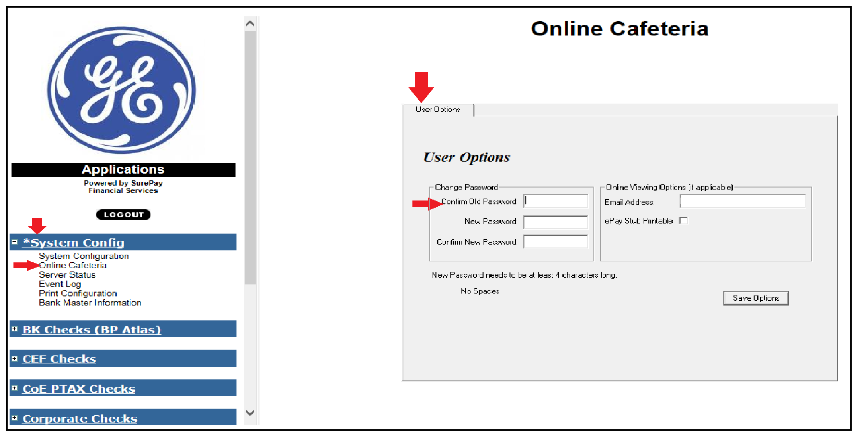

**Step 3:**

Go to Group Users tab -> select the Groups name associated with the user’s business -> Highlight the user’s sso in “Users in System” section and click the 🡨 arrow to add the user to the Assigned Users section.

Next click “Save” and then click OK on the popup window.

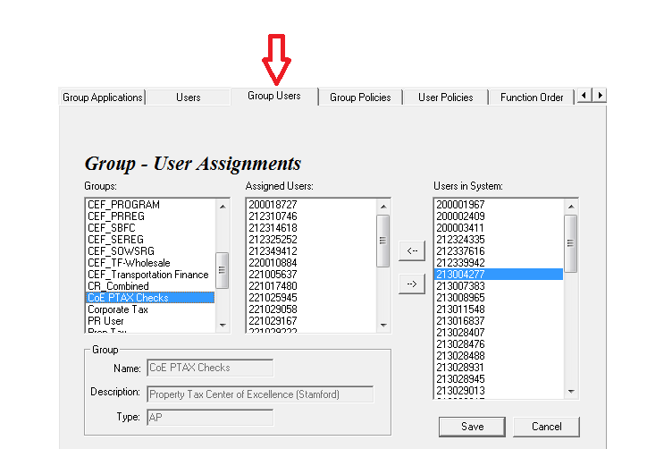

**Step 4:**

* Validate that user is added to the correct group
* Select User Policies tab -> validate if users group is correct or not. We can also assigned different functions using this tab depending on the requirements. Click on save once updated.

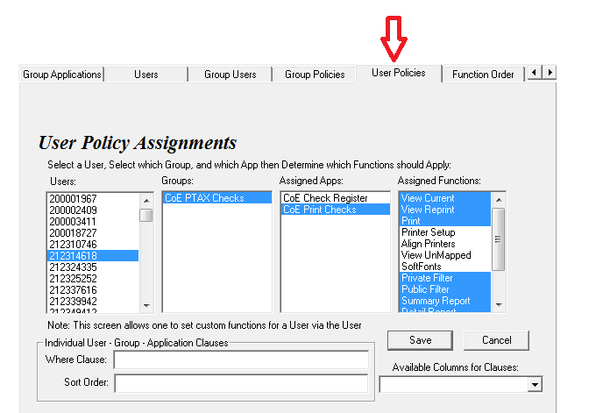

# Manually Requested Tasks

* **How to add/update Printer in Fiware:**

**For new printer:**

**Step 1**:

Go to Print Checks -> Click on Global Printer Setup

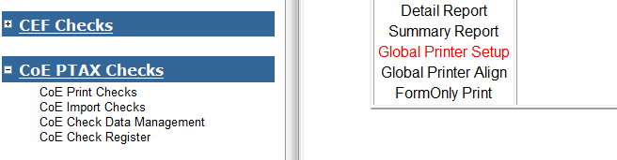

**Step 2:**

Click any existing printer -> Edit printer Alias name (username_business group_location)

Edit Printer port: Put actual printer name set up in user machine

Then click on Add (Ensure not to click on Update otherwise it will update the existing user). The new printer will be added.

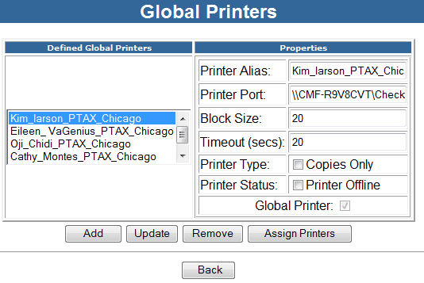

**Step 3:**

Select the printer and Click on Assign Printers to add user to the print. Move the user’s sso from right to left to users assigned to printer.

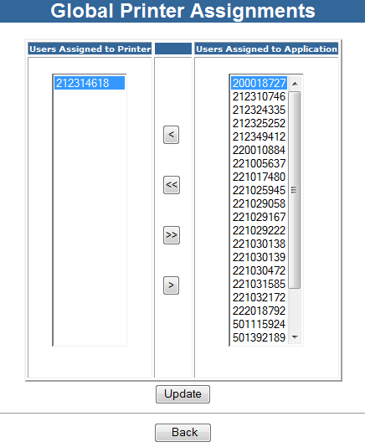

* **To update a printer.**

If a printer port needs to be updated then select printer name and edit/add correct printer name and port then click on update.

## Printer Setup

1. Click **Printer Setup**. The **User Printers** screen will appear. Enter the printer settings for the printer(s) to process the checks.

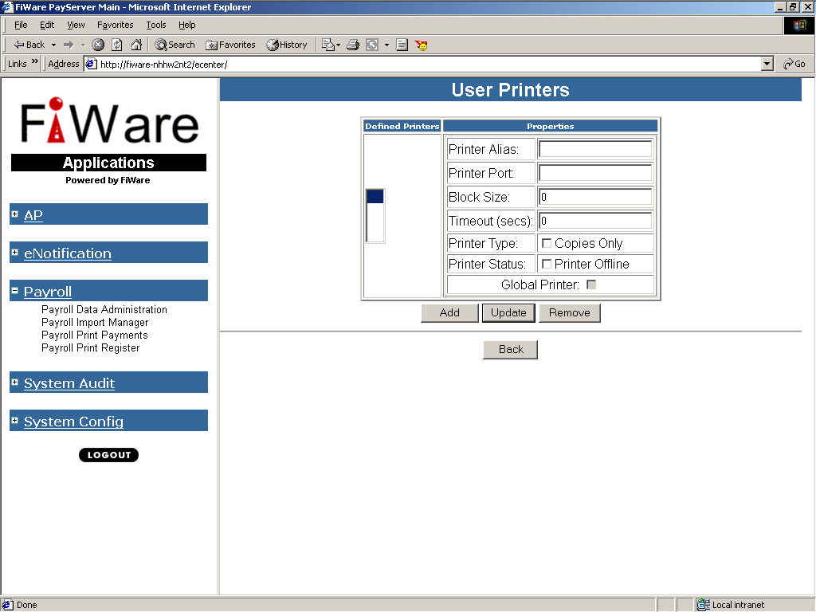

Note: **Before checks can be printed, the user must first configure the printers that will process the checks and make the proper form alignments. These setting are specific to the current user logged into eCenter.**

Printer Name specifies the printer port of a locally attached printer such as LPT1. Although is not recommended to print to networked printers for data security reasons, eCenter also supports UNC path names, (ex. \\CORPORATE\HP5SICORP).

Block Size specifies the number of records of data being transferred to the printer at a time. The value entered here is typically two times the printer’s page per minute value. This value must be greater than zero (0). A value of 10 is sufficient.

Timeout (secs) specifies the amount of time the printer waits before assuming the print job is complete.

Copies Only specifies if this printer will only print copies of the forms being printed. The print application must be configured to print copies in order for copies to actually print.

Printer Offline designates a printer as “Offline” if checked and “Online” if not checked. This feature allows for multiple printers to be configured and aligned in case of a primary printer failure.

Global Printer will auto-populate with a check if an administrator has designated the selected printer as Global. The check box will be grayed-out if the printer has not been designated as Global.

1. After entering values for each field, click Add. The printer will appear in the Defined Printers box.

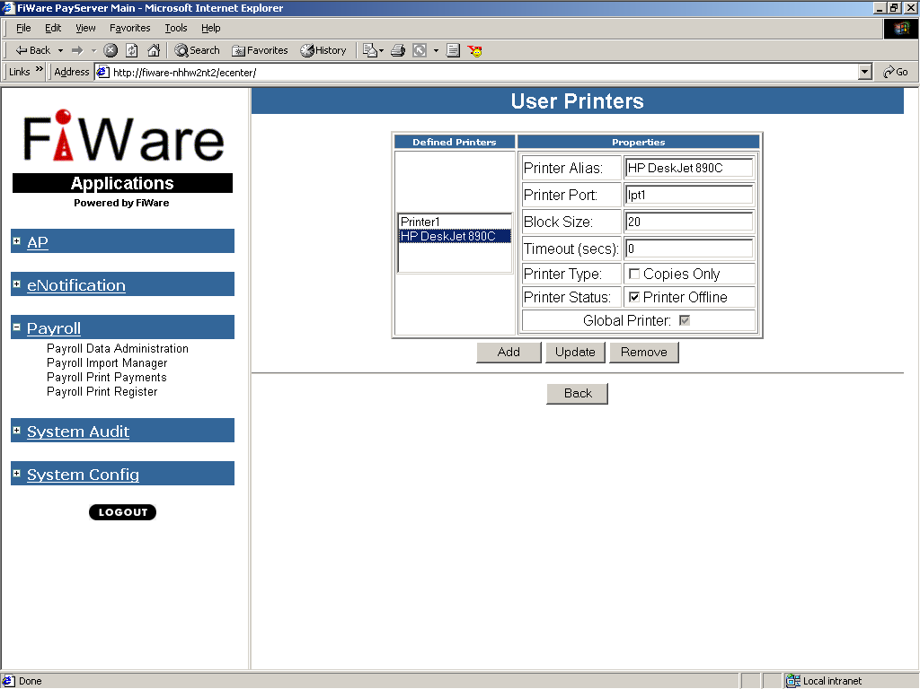

Note: **You may configure more than one printer. When multiple printers are defined, the print records will be evenly disbursed among all configured printers unless the additional printers are set to be Offline.**

To make changes to a configured printer, highlight the printer name, change the printer’s settings, and click **Update**. To **Delete** a configured printer, highlight the printer name, and click **Remove**.

1. Click **Back** to return to the prior screen.

## Align Printers

1. The check form must be properly aligned for your configured printer(s). Click Align Printers. The Align Printers screen will appear.

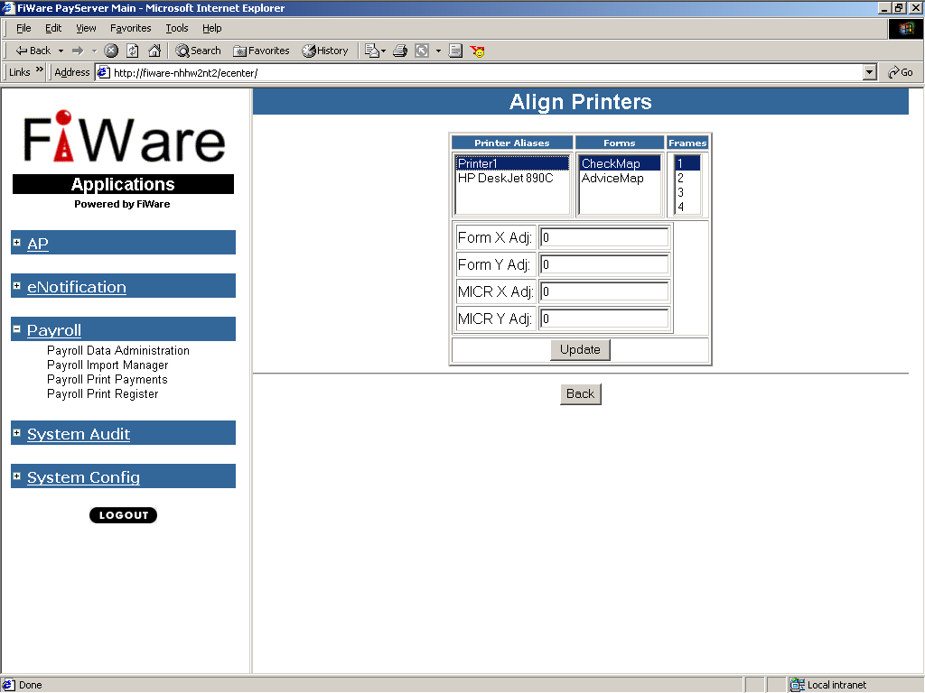

**Form X Adj** adjusts all form contents horizontally. A **positive value** moves the form’s contents to the **right**. A **negative value** moves the form’s contents to the **left**.

**Form Y Adj** adjusts all form contents vertically. A **positive value** moves the form’s contents **down**. A **negative value** moves the form’s contents **up**.

**MICR X Adj** adjusts the MICR line horizontally. A **positive value** moves the line to the **right**. A **negative value** moves the line to the **left**.

**MICR Y Adj** adjusts the MICR line vertically. A **positive value** moves the line **down**. A **negative value** moves the line **up**.

Note: **A value of –25 moves the corresponding field 25 millimeters up or left.**

**WARNING!** Before you a print your forms in a production cycle, use a MICR ruler to properly adjust your MICR setting. Then, you should submit test forms to your bank for their approval of the MICR settings.

**Note**: If your document was created to print more than one check per form, each check on the form is called a frame. The above settings may need to be adjusted for each frame.

1. Highlight the printer to be configured and the form. If necessary, enter values for each field. Click **Update** to save your changes. It may be necessary to enter unique values for each form. Click **Back** to return to the prior screen.

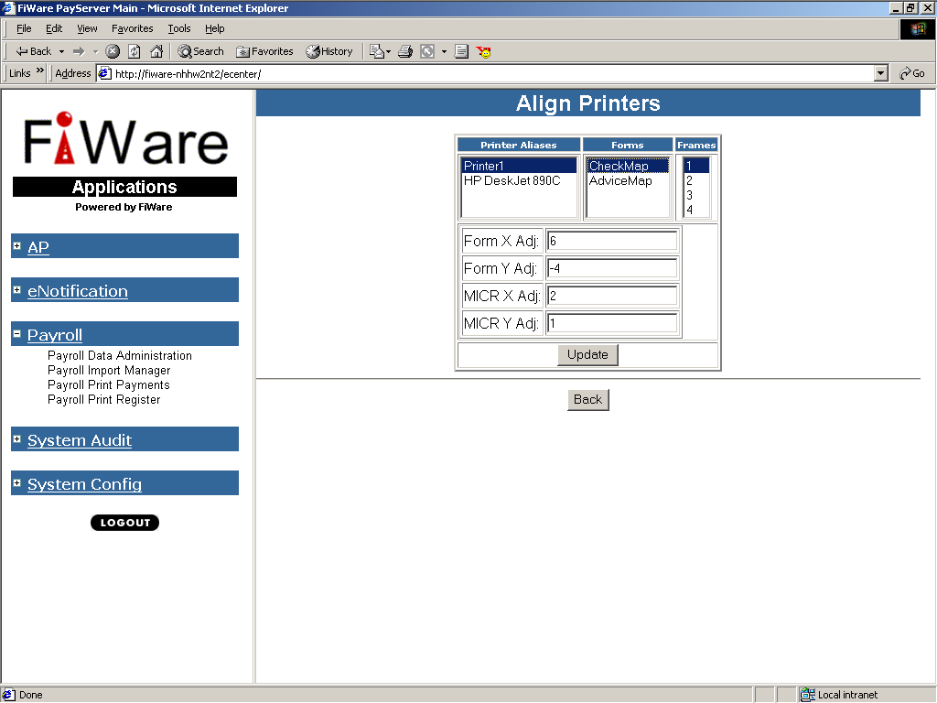

|  |
| --- |
| * **Fiware Logo/Signature/Check Form Change Process:** |

1. Business: Open a request using helpdesk service delivery form.
2. Fiware IT: Once request received, contacts user for further information.
3. Business: Provide sample check with logo/signature/Form to be changed highlighted.
4. Business: If logo change - provide new logo image.
5. Business: If Signature change - Fill up below signature template and send it back to Fiware IT.
6. Fiware IT: Contact Fiware third party vendor (surepay financials) requesting quote for changes.
7. Fiware vendor provides quote for changes requested.
8. Fiware IT: Send quote back to business for review and acceptance.
9. Business: Review, accept (sign) quote and send it back to Fiware IT.
10. Fiware IT: Send signed quote back to Fiware Vendor.
11. Fiware Vendor: Start the actual work and deliver required logo/signature.
12. Fiware IT: Setup new logo/signature/Form in Fiware DEV environment.
13. Business: Test new logo/signature/Form and validate results.
14. Business: Signoff on changes and approve for production deployment.
15. Fiware IT: Schedule changes to be deployed in production.
16. Business: Post production testing and signoff.
17. Fiware IT: Contact Fiware vendor and get the invoice for the changes done.
18. Fiware Vendor: Send invoice to Fiware IT.
19. Fiware IT: Send invoice to business.
20. Business: Setup the invoice for payment.

**Fiware IT Contact Information:**

* Thompson, Ronald (GE Capital)
* @CAPITAL AM OTR RUN CLIENT SERVER SUPPORT

**Fiware Vendor (Surepay) Contact Information:**

* Schiron Nichols : GE Account Representative

[snichols@surepayfs.com](mailto:snichols@surepayfs.com)

Digitizing Signature Template

Company:

Name:

(Name of person signing below – please print)

Place the same signature **COMPLETELY INSIDE** all three boxes in **BLACK** ink only.

**INCORRECT**

**CORRECT**

*Christian Alexander*

*Christian Alexander*

**NOTE:** FiWare reserves the right to choose the best signature from the three above to digitize based on appearance, readability, and correctness. If multiple signatures are needed, make copies of this form and complete as above. It is not necessary to complete this form for software upgrades unless this requires a signature change.

### Fiware Production Print Queues

|  |  |  |
| --- | --- | --- |
| Sr No. | Printer Path/Name | Printer Alias |
| 1 | \\dnc01pntcvfsge\CheckGen_DNC |  |
| 2 | \\CMF-F67S6R1\Doris_checkprinter | Doris Weber HFS |
| 3 | \\cmfcriapfiprp\vfs_cria_checkgen_cri | CheckGen_CRI |
| 4 | \\CAP-PC02TY7J\HEF_IFS_Checks | Angel Esteban - Jacsonville |
| 5 | \\cmfdnctpfiprp5\dnc3s06 | Lee Farm danbury |
| 6 | \\cmfdnctpfiprp5\dnc3s06 | Leefarm Danbury |
| 7 | \\CAP-4YN5M72\HEF_IFS_Checks | Donna A |
| 8 | \\CMF-PK0N2CX\Ben_Hentges_IRTX | Ben_Hentges_IRTX |
| 9 | \\CMF-FMJR4Q1\check_printer | Mandy_Padgett |
| 10 | \\CMF-4FH4FS1\Gwen_checkprinter | Gwendolyn Smith |
| 11 | \\G8VHK482E\Check_Printer | Maureen_State_Tax |
| 12 | \\cmfcriapfiprp\VFS_CRIA_CheckGen_CRI | Mandy_Padgett_New |
| 13 | \\CAP-GQLVZ52\CHECK_PRINTER_MT | Charles Warren - Billings |
| 14 | \\CMF-PK142P8\HEF_IFS_Checks | Nick Watson - Jacsonville |
| 15 | \\CAP-GQLVZ52\HEF_IFS_CHECKS | Charles_W_vfs |
| 16 | \\ACHECKPRIN00186\HPPCL6 | Amy_New_Printer |
| 17 | \\CMF-F67S6R1\Doris_checkprinter | Doris Weber |
| 18 | \\CAP-PC02TY2M\CHECK_PRINTER_MT | Angela Malek - Billings |
| 19 | \\CMFIRTXPFIPRP\CMF_IRTX_2_CHECKPR2 | Check Rapids new TX |
| 20 | \\ACHECKPRIN00186\HPPCL6 | Amy_State_Tax |
| 21 | \\CMF-FMJR4Q1\check_printer | Mandy Padgett |
| 22 | \\G8VHK482E\Check_Printer | lori_corp |
| 23 | \\cmfcriapfiprp\VFS_CRIA_CheckGen_CRI | Mandy Padgett_new |
| 24 | \\G8VHK482E\Check_Printer | Lori_State_Tax |
| 25 | LPT1 | Stamford PTAX Local Printer |

# Check Processing

* **Prod Manual check processing steps:**
* **Cause of manual check processing:**

There are two scenario in which checks did not process automatically, which are as follows:

1. If Import service is not running and service seems to be in stopped state then the checks will not be processed automatically because automatic check processing required import service to be running state during business hours. The un-processed check will be stay in the same business directory as per the business category.

If above issue occurred then follow below steps to process the checks manually.

**Step1** –

Open the Fiware Prod web server h16129-2.MGMT.CLOUD.DS.GE.COMwith your HPA ID or else service if applicable.

**Step2** –

Open the path **E:\Program Files\ecenter\FiWare_INPUT.**Above path is having all the directory according to the business segment.

Example: Like Albany checks having the folder name \**CORP_TAX,** similarly we have other directory present on above mentioned path.

**Step3** –

Check the business folder which is having issue. If the business file which was sent is present in the folder like **E:\Program Files\ecenter\FiWare_INPUT\CORP_TAX**We have to start the service manually.

**Step4** –

Open Task Manager -> Go to services tab -> in the service tab there is option to open service in additional mode.   
Once it’s opened, you will see lot of services listed there with the different ids.  
Now search the Import service.

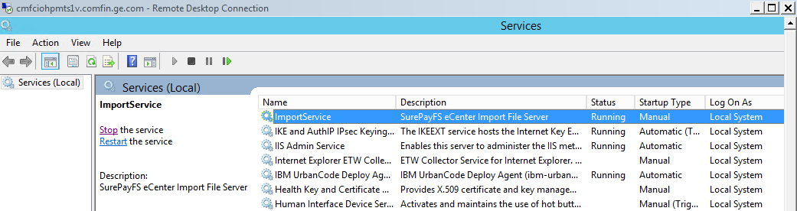

When such issues occurred then most of the time you will find the services will be stopped, in this case you may need to start the service.

**Step5** – Once the Import service is started successfully. Go to the same business directory (Step3) where the file was present. Now check and you will see that the files was processed and that will not be available there, that means it means the file has been processed successfully.

**Step6**- For safer side we have to fire below query in production database just to check the files which was processed is showing in database or not. If the files processed successfully then records will be updated in database with the current date.

select * from GECPTAX where IMPORTDATE=’sysdate’;

**Step7** – Now confirm the same with the business user who has raised a request.

1. If there is some issue in the files sent by business team to fiware directory then in that case the files went to error directory.

If above issue occurred then follow below steps to process the checks manually.

1. Login to App server. Navigate to directory **E:\Program Files\ecenter\FiWare_INPUT\CORP_TAX**

If not processed correctly, these will be moved to subfolder ErrorDir.

1. Check for any pending file in VFS folder or subfolder ErrorDir. **If the file is not processed and also not moved to ErrorDir, please restart Bossservice and Import service on the server**.
2. If you see file in ErrorDir after step one or setp 2, take backup of original file with _current_date and right click on file properties, uncheck Read-only attribute, click on advanced button and uncheck both option under file attributes. Click ok to save the changes and then cut the same file and paste it to the main directory and if it’s still going to Error directory that means the file is having issue.
3. Open the file and see the sequence, as per the fiware configuration it should have every check no should have associated with only one Invoice no. In some cases multiple Invoices are generated for same check no. because of that it’s not able to process the check file automatically.

Below is the example of multiple invoice issue:

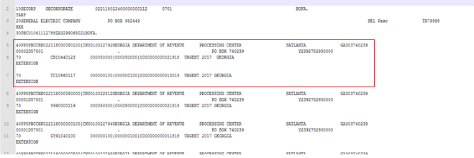

1. As we have taken backup of the original file, open the file in notepad and remove the whole checkno line till multiple invoice present.
2. Once the multiple invoice record removed from the file save the file and right click on file properties, uncheck Read-only attribute, click on advanced button and uncheck both option under file attributes.
3. Now place the file to main directory and after few seconds files will be processed automatically now you won’t be able to see the same file in error directory.
4. Once it’s successfully processed, fire below query in prod database as per the business category and see the check records will be update and present there to print.

select * from GECPTAX where IMPORTDATE=’sysdate’;

1. Now mail the business user with the error record, that the below check was having multiple invoice issue, due to that the checks were not processed automatically.
2. Business user will ask the Oracle COE team to void the check and once the check is voided business will re-generate the file for that check. We do not have to worry about that.

# Fiware Service Maintenance

* **Manual start and stop of Import and Boss services:**

**Step1** - Open the server PROD : h16129-2.MGMT.CLOUD.DS.GE.COM, UAT : h15332-2.mgmt.cloud.ds.ge. with the self HPA ID or service id which ever is fisibale.

**Step2** – Open the task manager

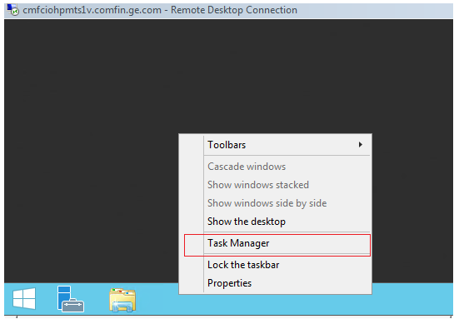

**Step3** - Once the task manager is opend you will see the below window, Now click on the **services** tab

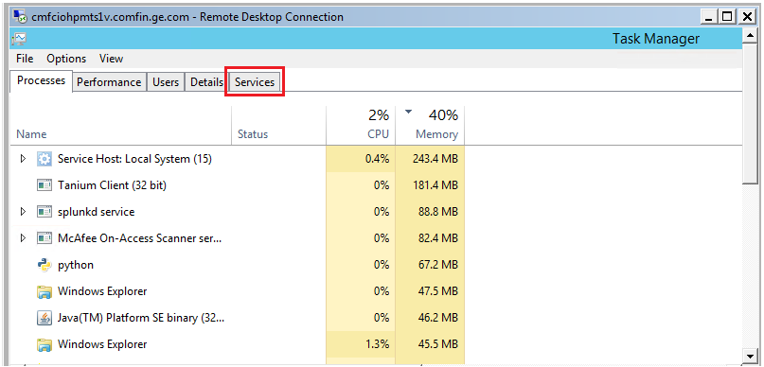

**Step4** - After opening the services tab you can see the Import and Boss services status, as follows:

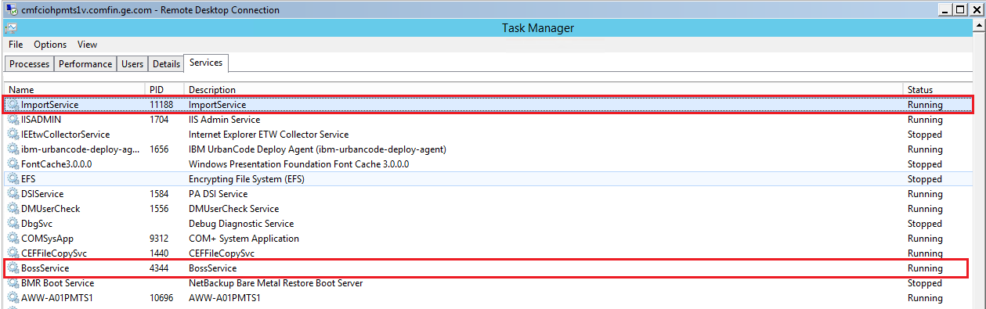

If the Boss and Import services showing in stopped state, you may have to start the services using below step.

**Step5** - In services tab, you will see the option to ***open services*** link in advanced mode.

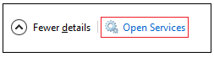

**Step6** –

Open the Services in advanced mode after clicking open services.

Now you will see the services, here if its showing stopped or status is whowing not running state then you may click on start/stop the services for both the Boss and Import services.

***Boss Service:***

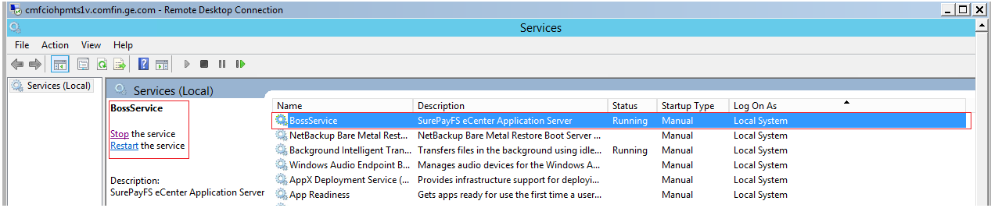

***Import Service:***

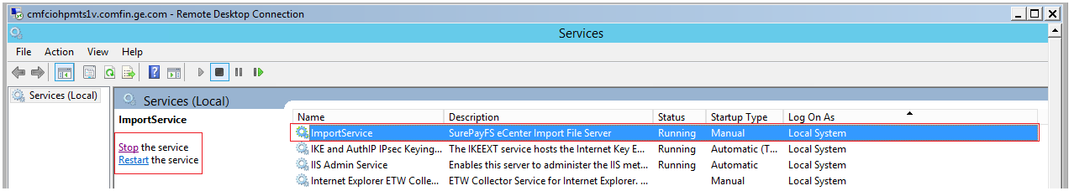

***Note:***

Boss services is for surepay web page and Import service is for automatic check processing.

If you are stopping/ starting the services manually then go with the same above mentioned sequences.

* **Globalscape Event Details:**

|  |  |  |  |  |  |  |  |  |  |  |  |  |  |  |
| --- | --- | --- | --- | --- | --- | --- | --- | --- | --- | --- | --- | --- | --- | --- |
| **Oracle SSS to Fiware** |  |  |  |  |  |  |  |  |  |  |  |  |  |  |
| QA | **lg807694sv==ID%1100163608==CI%sss source to pay (r12) - SSS AP PCT==Desc%paymentfile==ToGE_from==IP Name%Fiware==QA** | | | | | | | | | | | | | |
| PROD | **lg807694sv==ID%1100163608==CI%sss source to pay (r12) - SSS AP PCT==Desc%paymentfile==ToGE_from==IP Name%Fiware==PROD** | | | | | | | | | | | | | |
|  |  |  |  |  |  |  |  |  |  |  |  |  |  |  |
| **LeaseWave to Fiware** |  |  |  |  |  |  |  |  |  |  |  |  |  |  |
| QA | **li000084sd==ID%1216976==CI%Fiware==Desc%Fiware_files==FromGE_to==IP Name%Fiware==QA** | | | | | | | | | | | | | |
| PROD | **li000084sd==ID%1216976==CI%Fiware==Desc%Pull_Fiware_files_from_GEHC_server==FromGE_to==IP Name%GEHC Fiware==PROD** | | | | | | | | | | | | | |

# Monitoring Plan

* **Automatic Fiware Boss and Import service start and stop process:**
* We have created maintenance scripts which use to stop the Boss and Import services automatically at every day, **10:30 PM EST** through Task Scheduler on respective Fiware application servers.

Below is the snapshot of successful service **stopped**:

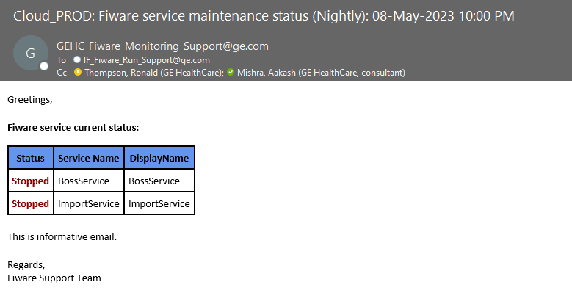

Below is the snapshot of successful service **Started**:

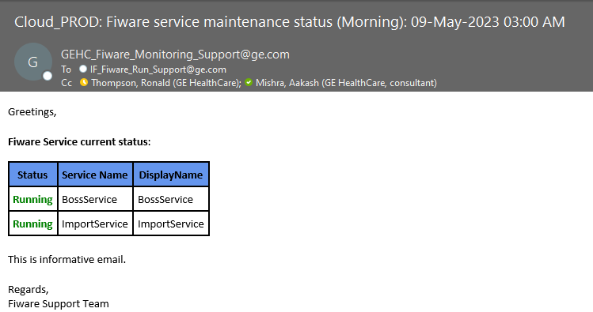

If you did not received the above mails or find any issues in services start or stop issues please contact the DL IF_Fiware_Run_Support@ge.com.

# Documentation

* eCenter Admin Manual:
* This Admin manual document has the installation procedure for Ecenter/Surepay.
* It is part of the complete ecenter documentation set which includes:
* **System Requirements**
* **eCenter Server Installation - New Install**
* **Configure eCenter Registry**
* **Configuring the eCenter Database**
* **BOSS Server Installation**
* **Logging into eCenter**
* **System Configuration**
* **Feature Setup**
* **Forms Configuration**
* **Database Management**
* **Event Logging**
* **eNotifications**
* **eCenter Admin Manual download Link :**

[**http://libraries.ge.com/download?fileid=909451412101&entity_id=69908971101&sid=101**](http://libraries.ge.com/download?fileid=909451412101&entity_id=69908971101&sid=101)

# Required Support Software

No special software required.

# FMEA

<THIS SHOULD BE PROVIDED BY THE BUILD TEAM>

This document is used to identify various places where failure can occur along with monitoring plans.



# Production Deployment

This is a third party owned software package. We never deploy code or patches.

Last application upgrade was done in 2017 by the SD Run Team based on instructions received from external vendor via the Fiware Build Team.

# Operational Procedures

## Application Health Check

* Task Scheduler task use to run after business hours 10:30 PM EST to stopped the Boss and Import services.
* Similarly, Task scheduler task use to run which use to start the BOSS and IMPORT services. If any issues happens then chain triggers the notification to mentioned Run team and application owner.

## Data Updates

There is no back-end data update done.

Whenever there is need to add/modify/delete user or bank acct details, it is done using application admin console.

## Batch Processing Monitoring

N/A. There is no batch processing for Fiware.

# Disaster Recovery

**DR Plan Fiware*.doc RHT: Update with new link to DR Plan**

# Server and Data Backup Details

* Fiware database is oracle. Database backup activity is done by Healthcare Oracle COE DBA team per GECA standards.
* Oracle team contact DL: @HEALTH IT DBA Operations – Oracle
* Database has daily cold backup scheduled at **3:15 AM EDT**.

# Communication Queues

* Run Team: IF_Fiware_Run_Support@ge.com
* Build Team: IF_Fiware_Run_Support@ge.com

# SLA

**Mission Critical Status: MC1**

**Production Uptime: 17/5 – M-F 5 AM - 10 PM EST**

**Primary User Times:** 9 AM EST – 7 PM EST (Monday – Friday)

**Build Team Availability:** N/A

**Build Team Escalation:** N/A

**Production Downtime:**

# Communication DL

Outage communication for **PROD** related issue should be sent to following DLs –

@Capital IF Fiware Users <IF_Fiware_Prod_Users@ge.com>

Outage communication for QA related issue should be sent to following DLs –

IF_Fiware_Run_Support@ge.com

[Philip.Reilly@ge.com](mailto:Philip.Reilly@ge.com)

Outage communication for PROD related issue should Be sent to following DLs –

Outage communication for PROD related issue should Be sent to following DLs –Outage communication for PROD related issue should Be sent to following DLs –Outage communication for PROD related issue should Be sent to following DLs –Outage communication for PROD related issue should Be sent to following DLs –

Outage communication for PROD related issue should Be sent to following DLs – @CS-ITO-Operations-team @CS-ITO-Operations-team

## Dependent Application Owner DL

No application is dependent on this application. Only users are updated.

# Contact List

|  |  |  |  |  |
| --- | --- | --- | --- | --- |
| **Business Contacts and Owners** | | | | |
| **Name** | **Work Phone** | **Cell Phone** | **SSO ID** | **Email** |
| Nash, Charles |  | +1 262 798 4496 | 212022569 | charles.nash@ge.com |

|  |  |  |  |  |
| --- | --- | --- | --- | --- |
| **Application Owner** | | | | |
| **Name** | **Work Phone** | **Cell Phone** | **SSO ID** | **Email** |
| Thompson, Ronald |  | +1 203 961 2489 | 200015696 | Ronald.Thompson1@ge.com |

|  |  |  |  |  |  |  |  |  |
| --- | --- | --- | --- | --- | --- | --- | --- | --- |
| **3rd Party Vendor- Surepay Financial Services** | | | | | | | | |
| **Name** | | **Role** | | **Work Phone** | | **Cell Phone** | | **Email** |
| Schiron Nichols | | Account Manager | | 800-404-0067 x 531 (office) | | 404-409-9026 | | snichols@surepayfs.com |
| Wade Brown | | Technical Acct Manager | | 1-800-832-4848 | | 404-602-0359 | | [wbrown@surepayfs.com](mailto:wbrown@surepayfs.com) |
| **Build Team** | | | | | | | | |
| **Name** | **Work Phone** | | **Cell Phone** | | **SSO ID** | | **Email** | |
|  |  | |  | |  | |  | |

|  |  |  |  |  |
| --- | --- | --- | --- | --- |
| **Run Team** | | | | |
| **Name** | **Work Phone** | **Cell Phone** | **SSO ID** | **Email** |
| Aakash Mishra | +91 9320 980927 | +91 9320 980927 | 5503026140 | Aakash.mishra@ge.com |
| Marutirtha Roy | +1 203 229 3829 | +1 203 229 3829 | 501220442 | roy.marutirtha@ge.com |

# MISC

Fiware is a third party owned software package owned by **SurePay Financial Services**.

We never deploy code or patches at our end.

* Service-Now CI : **fiware**
* Assert ID          : 1216976